**Satellite orbit altitudes**

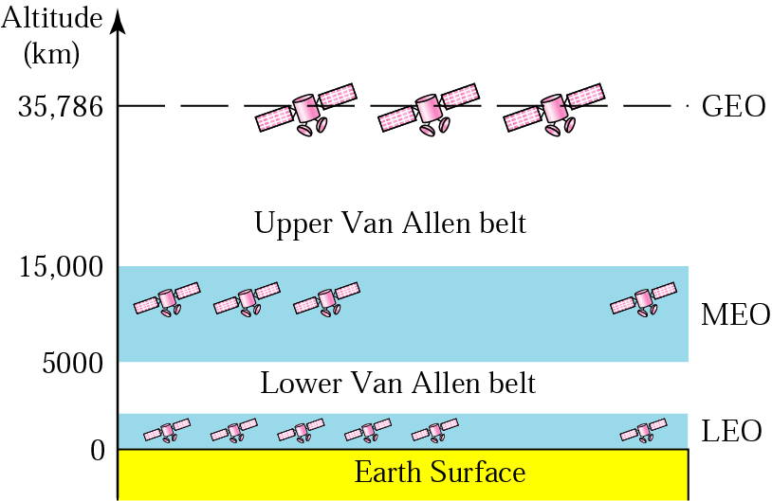

**(LEO) Low Earth Orbit**

LEO satellites are much closer to the earth than GEO satellites, ranging from 500 to 1,500 km above the surface.

LEO satellites don’t stay in fixed position relative to the surface, and are only visible for 15 to 20 minutes each pass.

A network of LEO satellites is necessary for LEO satellites to be useful.

**Medium Earth Orbit (MEO)**

A MEO satellite is in orbit somewhere between 8,000 km and 18,000 km above the earth’s surface.

MEO satellites are similar to LEO satellites in functionality.

MEO satellites are visible for much longer periods of time than LEO satellites, usually between 2 to 8 hours.

MEO satellites have a larger coverage area than LEO satellites.

**Geostationary Earth Orbit (GEO)**

These satellites are in orbit 35,863 km above the earth’s surface along the equator.

Objects in Geostationary orbit revolve around the earth at the same speed as the earth rotates. This means GEO satellites remain in the same position relative to the surface of earth

**First Launching Of Satellites By Country**

